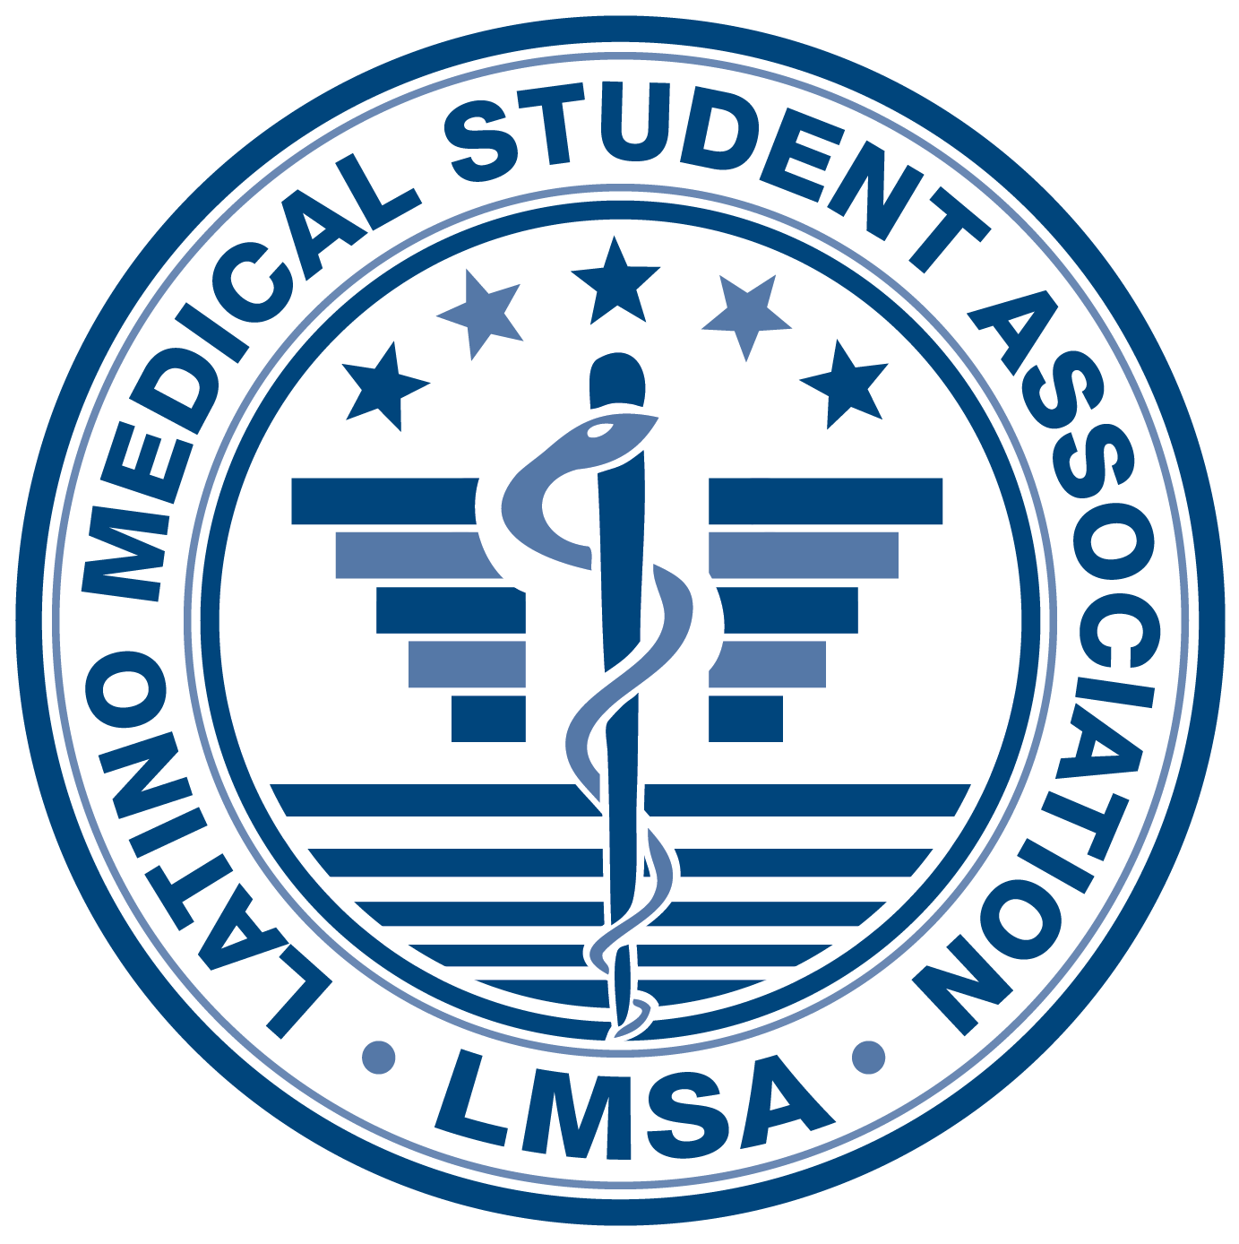

Latino Medical Student Association

DR. JOSE IGNACIO CHOCA SCHOLARSHIP

Latino Medical Student Association (LMSA) is a non-profit medical student organization that has been in existence since 1983 at the University of Illinois at Chicago-College of Medicine. Our goal is to provide academic support to Latino medical students and to recruit undergraduate and high school students who wish to pursue careers in medicine. Every year we offer a scholarship and that scholarship is awarded to an incoming first year University of Illinois at Chicago medical student. The LMSA Scholarship Committee will review the applications and select a student. The applicant selected will receive $500 for the upcoming academic year.

ELIGIBILITY

Applicants must be of Latin American descent, a U.S. citizen, permanent resident, or DACA recipient, and an incoming first year UICOM student.

SELECTION PROCESS

The Scholarship Committee will evaluate applicants based on all of the following criteria:
- Academic achievement
- Activities and honors
- Personal essay

APPLICATION DEADLINE

Applications must be received no later than August 24, 2022, at 11:59 PM CST. It is the applicant’s responsibility to ensure that all of the following materials are received prior to the deadline:
- Application
- Transcript (official or unofficial)
- Resume
- Personal Essay (500 words maximum; typed and double spaced)

All materials should be sent as PDFs in one email to: uiclmsa@gmail.com

Subject line: Dr. Jose Ignacio Choca Scholarship

Verification of acceptance and enrollment may be required if selected as a scholarship winner.

QUESTIONS

Please contact UIC LMSA at uiclmsa@gmail.com

Latino Medical Student Association

University of Illinois at Chicago College of Medicine

Dr. Jose Ignacio Choca Scholarship
Application

First Name:

Last Name:

Pronouns:

Address:

City: State: Zip Code:

Date of Birth:

Home Phone Number:

Father’s Occupation:

Mother’s Occupation:

Number of children in family under the age of 18:

Number of family members in college:

I certify that my statements on this application are true, complete, and correct to the best of my knowledge and belief. I understand that any falsification or omission of information may disqualify me from this scholarship. All information is completely confidential and will be released only in compliance with Federal and State Law.

__________________________________________ _____________
Applicant’s Signature Date

___________________________________________ _____________
Parent’s Signature (if Applicant is under 18 years of age) Date

ACADEMIC INFORMATION

Name of colleges/ universities attended

Major:

Cumulative GPA:

MCAT Score:

Please list any activities, honors, or awards you have received:

EXTRACURRICULAR ACTIVITIES

1. Please list current activities that demonstrate your community service or your social and cultural contributions to the Latino Community. (Please use a separate sheet if necessary.)

2. Please indicate up to three issues that need to be addressed in the health field today that relate to the Latino Community.

3. Pick one of the above issues and discuss specific recommendations you would make to correct or address the problem. (Please use a separate sheet if necessary.)

4. Please describe any obstacles that you have faced during your pursuit of an education. (Please use a separate sheet if necessary).

PERSONAL ESSAY (500 words maximum; typed and double spaced)

Tell us what inspired you to pursue medicine and how you will help advance the state of health-care and education in Latino and underserved communities as a future physician

